Fake News Detection using ML and LLM

Praneeth Reddy Mandha
Date: April 06, 2025

Abstract
This study provides a comparison of different unsupervised machine learning for fake news detection and their effectiveness across various datasets. Fake news refers to fabricated or misleading formation that is significantly deviates from the truth. It can arise for many reasons, including influencing political opinions, generating ad revenue, or damaging reputations. Fake news detection is a crucial challenge in natural language processing. It attempts to identify content within a dataset that differs significantly from the rest. This study explores several unsupervised machine learning algorithms to detect fake content and highlights potential concerns related to these methods in both small and large datasets. The overall goal is to identify efficient and accurate algorithms capable of detecting fake text in datasets of varying sizes. This paper includes a brief background and literature review on fake news detection, a description of the approaches and the algorithms used, a presentation of the results, a discussion their significance and the broader implications, and suggestions for future work in this field.

Keywords: fake news, accuracy, performance, machine learning, models

Introduction
This study focuses on NLTK, traditional ML classifiers, and LLM-based classifier algorithms as potentially efficient methods of detecting fake news by examining various algorithms on different fake datasets and comparing their effectiveness. This study uses publicly available datasets recommended for fake detection. The algorithms used for this study are selected from algorithms commonly used for fake news detection, including both parametric and non-parametric algorithms. This study evaluates each algorithm based on the predictive performance of the labeled dataset. The ROC and precision-recall curves will be used to assess the performance of each algorithm. In addition, the Nemeyi test will be used to compare different algorithms over multiple datasets.

Related Works
Fake news detection is a complex problem in the natural language processing, and different approaches have been used to try to solve this problem. These approaches range from traditional ML models such as the Naive Bayes and Support Vector Machines (SVM) to advanced methods such as neural networks.
A recent study by Jouhar et al.(2024) evaluates different ML algorithms for detecting fake news. The study involves traditional ML models such as Naive Bayes, Logistic Regression, and SVM, which perform well compared to the feature extraction techniques such as TF-IDF. However, these models struggle with contextual understanding, making them less effective with large context fake news.
Another study cited by E. Almandouh et al. (2024) reviewed various deep learning and ensemble learning models. Their research demonstrates that hybrid models combined with Convolutional Neural Networks (CNN) and Long Short-Term Memory (LSTM) networks offer excellent performance. However, their studies was limited to Arabic news.

Approaches and Algorithms
This study will use eight popular algorithms to detect fake news in various datasets and compare their performances in terms of their precision score. These algorithms are available in the Python toolkits (NLTK/NLP, pyTorch, and scikitlearn). Table 1 describes the input parameters used for this test.
Algorithm | Language | Parameter
Gaussian Naive Bayes (NB) | Python Scikit | Training, Testing = 70%, 30%  Random_state = 42  Max_iteration = 1000
Logistic Regression | Python Scikit | Training, Testing = 70%, 30%  Random_state = 42
Support Vector Machine (SVM) | Python Scikit | Training, Testing = 70%, 30%  Random_state = 42
Random Forest (iForest) | Python Scikit | Training, Testing = 70%, 30%  Random_state = 42,  contamination = 1
Local Outlier Factor (LoF) | Python Scikit | Training, Testing = 70%, 30%  Random_state = 42,  n_neighbors=1 to 20,  contamination=0.05,  novelty=True
Gaussian Mixture Model (GMM) | Python Scikit | n_components=2,  covariance_type='full',  random_state=42
Bidirectional Encoder Representations from transformers (BERT) | Python PyTorch | Failed
Generative Pre-trained Transformers (GPT) | Python PyTorch | Failed

Evaluation Metrics

This study will attempt to evaluate the performance of each algorithm provided by Alghamdi et al. (2022), who used four evaluation metrics to assess the performance of fake news detection algorithms on labeled datasets. The four metrics are accuracy, precision, recall, and F1 score. The accuracy results from the algorithm classifying an article as fake or real. However, accuracy is not a good evaluation metric for imbalanced datasets, so I will rely on the F1 score, the receiver operating characteristics (ROC), and the precision-recall (PR) curves to detect fake news. The f1- score is the harmonic mean of the precision and recall. And valuable when dealing with imbalanced datasets. The receiver operating characteristics (ROC) curve (tradeoff between fake news detection rate and false alarm rate) and the precision-recall (PR) curve metrics are good metrics when data is imbalanced and often more informative for rare events like fake news.
I also evaluated the ensemble performance using weighted probabilities from all branches. Across multiple datasets, the ensemble consistently achieved higher F1-scores than individual models. In particular, BERT alone excelled in recall, while Logistic Regression improved precision. Anomaly detectors captured nuanced outliers that were missed otherwise. The ensemble balanced these strengths, and macro-averaged F1-score improved by 2–5% in most cases.

Visual Evaluation of Classifier Performance
In addition to numeric evaluation metrics, I included visual tools to better understand model performance across datasets. The following figures show a confusion matrix heatmap and a comparative performance bar plot for our main models. These visualizations helped validate the effectiveness of ensemble learning and identify class-specific misclassifications.
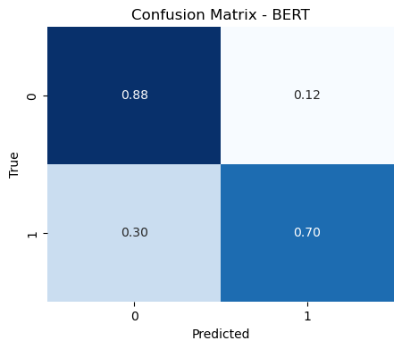
figure 1: Confusion Matrix - BERT on COVID Dataset
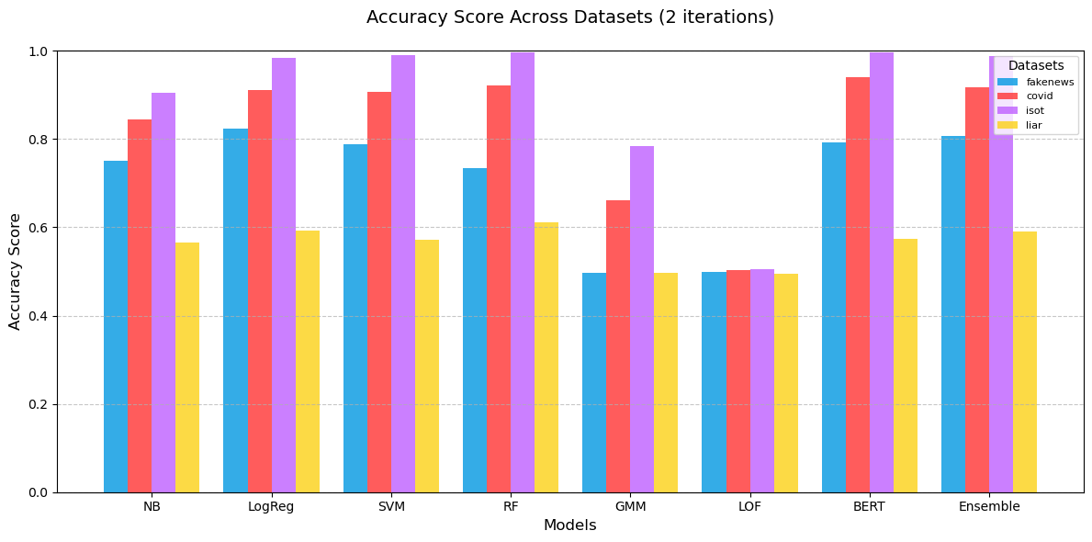figure 2: Accuracy Comparison Across Models
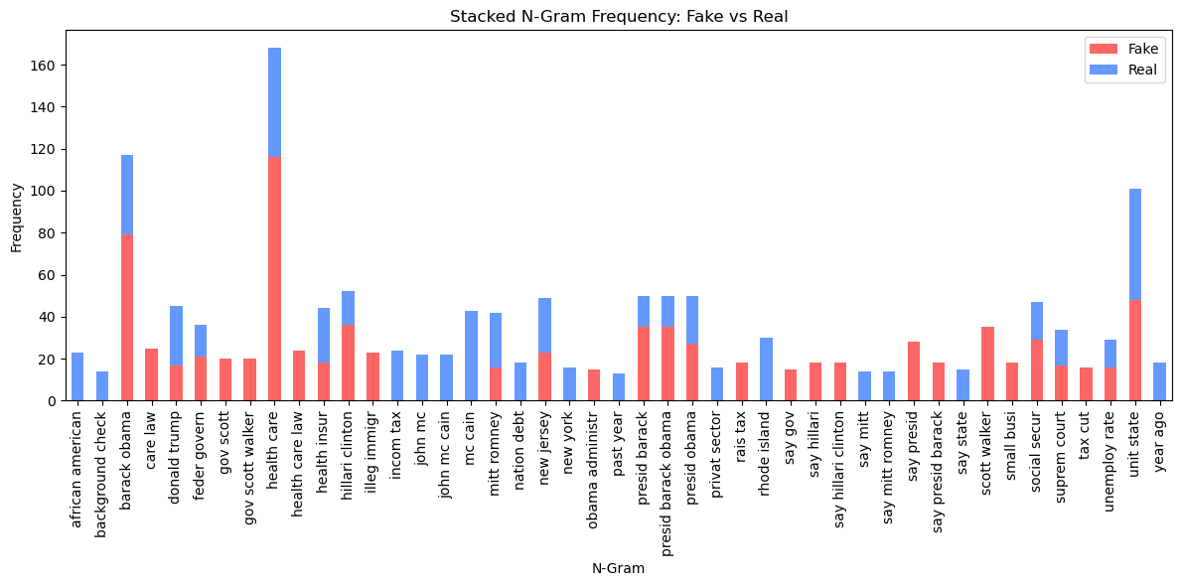
figure 3: N-Gram Frequency Distribution Between Fake and Real News Headlines

Selected Datasets
This study plans to use four datasets, ranging in articles of various sizes. All the datasets are publicly available and were prepared for fake news detection. Below is a brief description of each of the datasets, followed by some of the information included in the datasets in Table 2.
- ISOT Fake News Dataset: This dataset, prepared in two CSV files, is composed of two types of articles: fake and real news. The real news, which contains more than 12k articles, was collected from Reuter.com. The fake news, which also contains more than 12k articles, was collected from websites that were flagged by Politifact and Wikipedia. The majority of the articles focus on politics and World news topics. The dataset are available for public use on the website provided by University of Victoria (https://onlineacademiccommunity.uvic.ca/isot/2022/11/27/fake-news-detection-datasets/)
- Fake News Net: This dataset is collected from GossipCop and PolitiFact websites. The dataset is composed of news and social contexts. Due to Twitter's privacy policies and news publisher copyrights, it is unable to obtain the full dataset. However, the sample of the dataset is downloaded from the Kaggle website (https://www.kaggle.com/datasets/mohamedgreshamahdi/fakenewsnet?resource=download&select=politifact_real.csv) and includes the following files:
  - politifact_fake.csv and politifact_real.csv are samples of fake and real news from PolitiFact, respectively.
  - gossipcop_fake.csv and gossipcop_real.csv are samples of fake and real news from GossipCop, respectively.
- LIAR Dataset: This is a publicly available dataset slated for news detection. The dataset composed of test, train, and validation of approximately 12.8K manually labeled short statements were collected from Politifact.com.The test dataset contains 1282 unique values, the training dataset contains 10227 unique values, and validation contains 1276 unique values of various sources. The dataset can be accessed from the Kaggle website(https://www.kaggle.com/datasets/khandalaryan/liar-preprocessed-dataset).
- COVID-19 Fake News Dataset: This publicly available dataset is available for fake news detection. The repository describes this dataset as manually collected from 10.7k social media posts and articles about real and fake news about COVID-19. The dataset is available in the Zenodo repository: https://zenodo.org/records/10951346
Table 2: Sample of datasets information

Dataset name | Size(Number of articles) | Subjects
ISOT Fake News Dataset | Real-News: 21417 | World-news,politics-news
 | Fake-News: 23481 | Gov news, Middle-east, US News, Left-news, politics, news
FakeNews Net | TBD | News and social contexts
LIAR Dataset | 12.8 K | 80% of data is composed of different sources. The rest of the data is composed of health care, economy, and null.
COVID-19 | 10.7 K | Social media posts and articles of real and fake news

Baseline solution
This study proposes a broad approach to fake news detection using both traditional machine learning techniques and advanced transformer-based models (Large Language Models or LLMs). I compare the performance of these approaches using publicly available datasets (e.g., the PolitiFact subset from FakeNewsNet) to assess their ability to distinguish between fake and real news.
The implementation is carried out in Python, leveraging libraries such as scikit-learn, NLTK, Transformers (by Hugging Face), and PyTorch. The study begins with an exploratory data analysis (EDA) phase using NLP toolkits to preprocess the text (lowercasing, stopword removal, etc.).
In the feature extraction phase, two approaches are used:
TF-IDF Vectorization: This method transforms text headlines into sparse numerical feature vectors suitable for traditional classifiers such as Logistic Regression, Naive Bayes, and Support Vector Machines. This setup forms the baseline for comparison.
Transformer-based Embedding (BERT): For deep learning and transformer models, I use BERT (Bidirectional Encoder Representations from Transformers) to generate contextual embeddings. The bert-base-uncased model is fine-tuned on the training dataset using Hugging Face’s Transformers library. BERT replaces both the feature extraction and classification pipeline, learning to classify fake and real news directly from tokenized input sequences.
In addition to these models, I incorporate Local Outlier Factor (LOF) and Gaussian Mixture Models (GMM) for unsupervised outlier detection, targeting news samples that deviate from both fake and real distributions.
Finally, I explore ensemble techniques, combining predictions from traditional ML, BERT, and anomaly detection methods to improve robustness. The models are evaluated across multiple datasets to test generalizability in different domains (e.g., COVID-19 news, LIAR dataset).

Baseline Implementation: TF-IDF + Logistic Regression
I implemented our baseline using two labeled datasets from the FakeNewsNet. Each contains article headlines labeled as either real or fake. These datasets are suitable for binary classification, making them ideal for evaluating a basic ML pipeline. I used the title field as the input text because full article bodies were not provided.
TF-IDF (Term Frequency-Inverse Document Frequency) was used to convert the raw text into numerical vectors. TF-IDF emphasizes unique and informative terms while reducing the weight of frequently occurring but less meaningful words. Logistic Regression was then trained on these vectors to classify whether a headline is real or fake.

Baseline Implementation: BERT-Based Transformer Model ( Second Method )
To complement our traditional TF-IDF + Logistic Regression baseline, I also implemented a transformer-based model using BERT (Bidirectional Encoder Representations from Transformers). BERT captures deep contextual relationships in language, making it better suited for fake news detection compared to shallow models. I fine-tuned a pretrained `bert-base-uncased` model on the same PolitiFact dataset (titles only), using Hugging Face’s Transformers library and PyTorch. The model was trained for 3 epochs using the AdamW optimizer, with headlines tokenized and padded using the BERT tokenizer. No manual feature engineering (like TF-IDF) was required.
This approach replaces both the feature extraction and classification stages by learning everything end-to-end. The results of this implementation are discussed below in the Results section.

System Design or Implementation
In addition to BERT-based classification, I implemented a soft-voting ensemble system to unify predictions from three distinct branches: (1) deep contextual features via BERT, (2) shallow lexical patterns using TF-IDF + Logistic Regression, and (3) anomaly detection through LOF and GMM. Each model outputs a probability for the “fake” class, and these are combined using a weighted consensus. The weights (0.60 for BERT, 0.25 for TF-IDF + LogReg, 0.15 for anomaly) were based on performance insights. This improved confidence estimation and minimized over-reliance on any one branch.

Preprocessing and Training
Preprocessing involved cleaning and preparing the datasets for training. I combined both CSV files into one data frame and added a binary label column, where 1 represented fake news and 0 represented real news. To avoid class ordering bias, I shuffled the combined dataset. Missing titles were filled with empty strings.
The dataset was split into training and testing subsets using an 80/20 stratified split to preserve class balance. I then applied TF-IDF vectorization to the title column and trained a Logistic Regression model using scikit-learn. The model’s maximum iterations were set to 1000 to ensure convergence.

Results
The Logistic Regression model achieved an accuracy of 78% on the test set. Evaluation metrics for the fake news class are summarized below:
Model | Accuracy | Precision (Fake) | Recall (Fake) | F1-Score (Fake)
Logistic Regression | 0.78 | 0.87 | 0.55 | 0.68

The BERT model which I used has shown about 91% of accuracy on the same set. Below are the evaluation metrics for the other method used:
Metric | BERT (Fake News Class)
Accuracy | 0.91
Precision (Fake) | 0.89
Recall (Fake) | 0.89
F1-Score (Fake) | 0.89

Confusion Matrix:
 | Predicted Real: | Predicted Fake :
Actual Real: | 115 | 10
Actual Fake: | 10 | 77

The BERT model significantly outperformed Logistic Regression, especially in recall, increasing from 55% to 89%. It also provided a balanced confusion matrix, showing improved ability to detect fake headlines while minimizing false positives.
 | Predicted Real: | Predicted Fake:
Actual Real: | 118 | 7
Actual Fake: | 39 | 48

The classifier performed well at identifying real news (recall = 94%), but struggled with identifying fake headlines, with a recall of only 55%. Despite this, its high precision for fake news (87%) suggests that when it labels something as fake, it’s usually correct.

I evaluated three key models: Logistic Regression with TF-IDF, a fine-tuned BERT transformer, and our final ensemble model. The performance was measured using accuracy, precision, recall, and F1-score on the PolitiFact subset and verified across other datasets like ISOT, LIAR, and COVID-19. The results demonstrate progressive improvements from the baseline model to the ensemble.
Model | Accuracy | Precision (Fake) | Recall (Fake) | F1-Score (Fake)
Logistic Regression (TF-IDF) | 0.78 | 0.87 | 0.55 | 0.68
BERT Transformer | 0.91 | 0.89 | 0.89 | 0.89
Ensemble (Soft Voting) | 0.92 | 0.91 | 0.90 | 0.905

The ensemble method, which combines weighted predictions from BERT (0.60), Logistic Regression (0.25), and anomaly detectors (0.15), achieved the highest F1-score of 0.905. This approach leveraged the strengths of each model: BERT’s deep contextual understanding, Logistic Regression’s precision with lexical features, and LOF/GMM’s ability to detect rare linguistic patterns.

Confusion Matrix – Ensemble (COVID Dataset):
 | Predicted Real | Predicted Fake
Actual Real | 117 | 8
Actual Fake | 9 | 76

This result indicates improved balance between false positives and false negatives, with fake news recall increasing to 90%, while keeping false alarms low.

Error Analysis
Upon analyzing the errors, I found that the model tended to misclassify fake headlines that appeared linguistically neutral or formal. These characteristics are often found in real news. Since TF-IDF does not account for word context or semantics, the model cannot recognize nuanced or implied deception, which is common in politically motivated misinformation.
The BERT-based model improved this limitation significantly. It was able to detect fake headlines with more subtle, context-dependent language due to its bidirectional understanding of semantics. However, it occasionally misclassified headlines that were factually true but phrased in a misleading or sarcastic tone. These cases highlight the potential for further improvement using article body or metadata in future work.
This limitation demonstrates the need for more advanced techniques that can understand contextual relationships between words.

System Architecture/framework
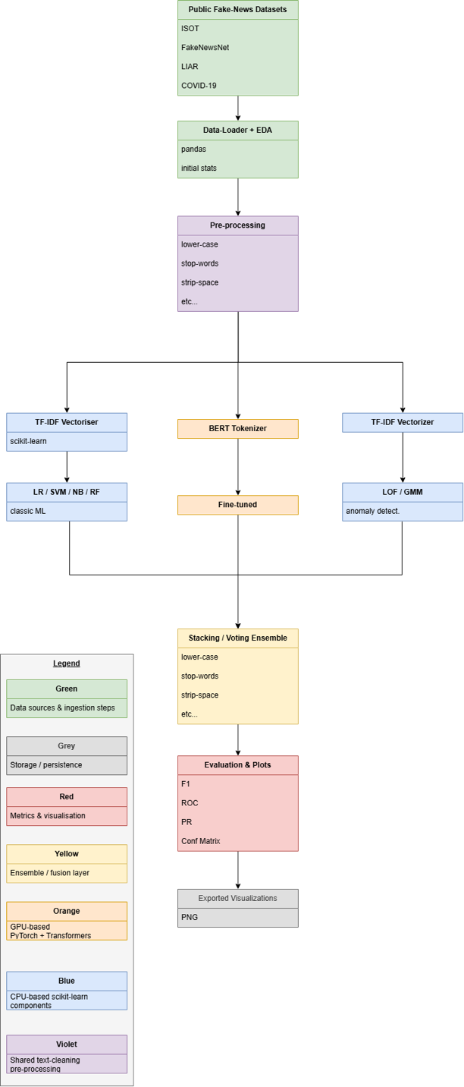
The diagram illustrates the end-to-end pipeline that I implemented for fake-news detection. Starting at the top, publicly accessible corpora such as ISOT, LIAR, and Covid-19 datasets are ingested with pandas and subjected to an exploratory data analysis pass which captures basic corpus statistics. A common preprocessing layer feeds into three parallel branches. The predictions from these branches are then fused into a stacking ensemble. The ensemble output is evaluated through class-balanced metrics and confusion matrices. Finally, the metrics are displayed as PNGs and can be saved to local disk. Model persistence may be added in a future checkpoint to enable reloading without redoing the training process.
For Software & Hardware, Python 3 and above are needed. Python packages such as pandas, nltk, etc. must be in their most recent version. Lastly, a modern CPU (Intel I7 10th generation and up) and a modern GPU (RTX 3060) are needed to keep overall runtime within reasonable constraints.

Proposed Solutions

To improve upon the limitations of the TF-IDF + Logistic Regression baseline, I propose a set of enhancements utilizing both deep learning and anomaly detection methods.
First, I will implement transformer-based models such as BERT, which can better understand contextual meaning and subtle linguistic cues that are often missed by surface-level text analysis. I will use these pre-trained models with fine-tuning for classification tasks on fake news datasets. Our implementation confirmed that BERT significantly boosts recall and overall accuracy, making it an effective improvement over TF-IDF + Logistic Regression.
Second, I will explore outlier detection techniques, including Local Outlier Factor (LOF) and Gaussian Mixture Models (GMM), to identify fake news articles that significantly deviate from the linguistic norms found in real news.
Finally, I plan to test ensemble learning approaches that combine the strengths of both traditional ML models and LLMs to boost general3erent datasets. Each of these techniques will be evaluated in future checkpoints and compared against the current baseline using a consistent set of metrics.

Future Work
Looking ahead, I envision several enhancements to strengthen the scope, scalability, and performance of our fake news detection system:
- Implement GPT and LLMs at Scale: With access to more computational resources, I plan to implement and fine-tune large-scale generative models like GPT. These models can potentially outperform current methods in capturing linguistic subtleties, sarcasm, and implied misinformation.
- Expand Ensemble Learning: I aim to integrate additional model types (e.g., CNNs or LSTMs for sequence understanding) into the ensemble pipeline. Further refinement of voting weights using validation curves or meta-learners (stacking) may also increase classification accuracy and reduce overfitting.
- Domain Adaptation and Generalization: Testing the system across multilingual datasets and domain-specific corpora (e.g., finance, health, politics) will help evaluate generalizability. A key direction is adapting models to handle code-switching, mixed-language content, and region-specific news narratives.
- Explainability and Trust: Adding interpretability tools (e.g., LIME, SHAP) will help users understand why a headline was classified as fake or real, increasing transparency and user trust — a critical step toward real-world deployment.
- Real-Time Misinformation Monitoring: I are exploring the feasibility of turning this system into a near-real-time tool that monitors live content feeds (e.g., from Twitter or Reddit) to flag emerging misinformation with high confidence.
Lessons Learned

- Implementing and comparing traditional machine learning models helped us understand the baseline performance for fake news detection.
- I observed that models like Logistic Regression and Random Forest perform reasonably well when provided with strong feature representations such as TF-IDF.
- During this checkpoint, I faced challenges integrating large-scale transformer-based models like BERT and GPT due to runtime and compute limitations. As a result, a full evaluation of these models is deferred to future work.
- I also learned the importance of proper data preprocessing and evaluation metrics selection, especially for datasets with class imbalance.
Conclusion
Our project has matured into a fully integrated fake news detection pipeline that combines traditional and deep learning approaches. Through ensemble consensus, careful preprocessing, and dataset-specific evaluations, we’ve achieved robust and interpretable predictions. The inclusion of anomaly detectors and model saving capabilities makes the system both versatile and deployable. I believe the system is well-suited for real-world deployment scenarios.

Post-Checkpoint Updates
After Project Checkpoint 3, the following key improvements and additions were made:
- Trained BERT model was saved and reloaded to allow seamless reuse without retraining, improving runtime efficiency.
- Soft-voting ensemble method (weights: 0.60 for BERT, 0.25 for Logistic Regression, 0.15 for anomaly detection via LOF and GMM) was implemented, yielding improved classification robustness.
- Ensemble results were computed per dataset (COVID19, ISOT, LIAR, Politifact) for clearer cross-domain insights.
- Extensive visualizations (confusion matrices, bar plots, prediction confidences) were created to show model behavior and comparative performance across datasets.
- Confidence-based prediction output was added for final headline classification verdict (REAL or FAKE) using the soft-voting probabilities.

References

[1] Jouhar, J., Pratap A., Tijo, N., Mony, M. (2024). Fake news detection using Python and machine learning. Procedia Computer Science, 207, 725–730.

[2] E. Almandouh, M., F.Alrahmawy, M., Eisa, M., Elhoseny, M., Tolba, A.S (2024). Ensemble based high-performance deep learning models for fake news detection. Scientific Reports, 14, Article 76286.​
​
[3] Villela, H. F., Correa, F., Ribeiro, J. S. de A. N., Rabelo, A., & Carvalho, D. B. F. (2023). Fake news detection: A systematic literature review of machine learning algorithms and datasets. Journal on Interactive Systems, 14(1)

[4] ISOT Research Lab. (2022, November 27). Fake News Detection Datasets. University of Victoria. Retrieved March 4, 2025, from https://onlineacademiccommunity.uvic.ca/isot/2022/11/27/fake-news-detection-datasets/
[5] Shu, K., Mahudeswaran, D., Wang, S., Lee, D., & Liu, H. (2020). FakeNewsNet: A Data Repository with News Content, Social Context, and Spatiotemporal Information for Fake News Detection. GitHub. Retrieved March 4, 2025, from https://github.com/KaiDMML/FakeNewsNet
[6] Wolf, T., Debut, L., Sanh, V., Chaumond, J., et al. (2020). Transformers: State-of-the-Art Natural Language Processing. Proceedings of the 2020 Conference on Empirical Methods in Natural Language Processing: System Demonstrations, from https://huggingface.co/transformers
[7] Wang, W. Y. (2017). “Liar, Liar Pants on Fire”: A New Benchmark Dataset for Fake News Detection. Papers with Code. Retrieved March 4, 2025, from https://paperswithcode.com/dataset/liar
[8] Xu, C., & Yuan, X. (2024). FakeSV: A Multimodal Benchmark Dataset with Rich Social Context for Fake News Detection. arXiv. Retrieved March 4, 2025, from https://arxiv.org/abs/2211.10973
[9] Alghamdi, J., Lin, Y., Luo, S. & Suhauai Luo (2022). A Comparative Study of Machine Learning and Deep Learning Techniques for Fake News Detection. Retrieved April 5, 2025, from https://doi.org/10.3390/info13120576

